**80KW DC Fast EV Charger**

**Instruction Manual**

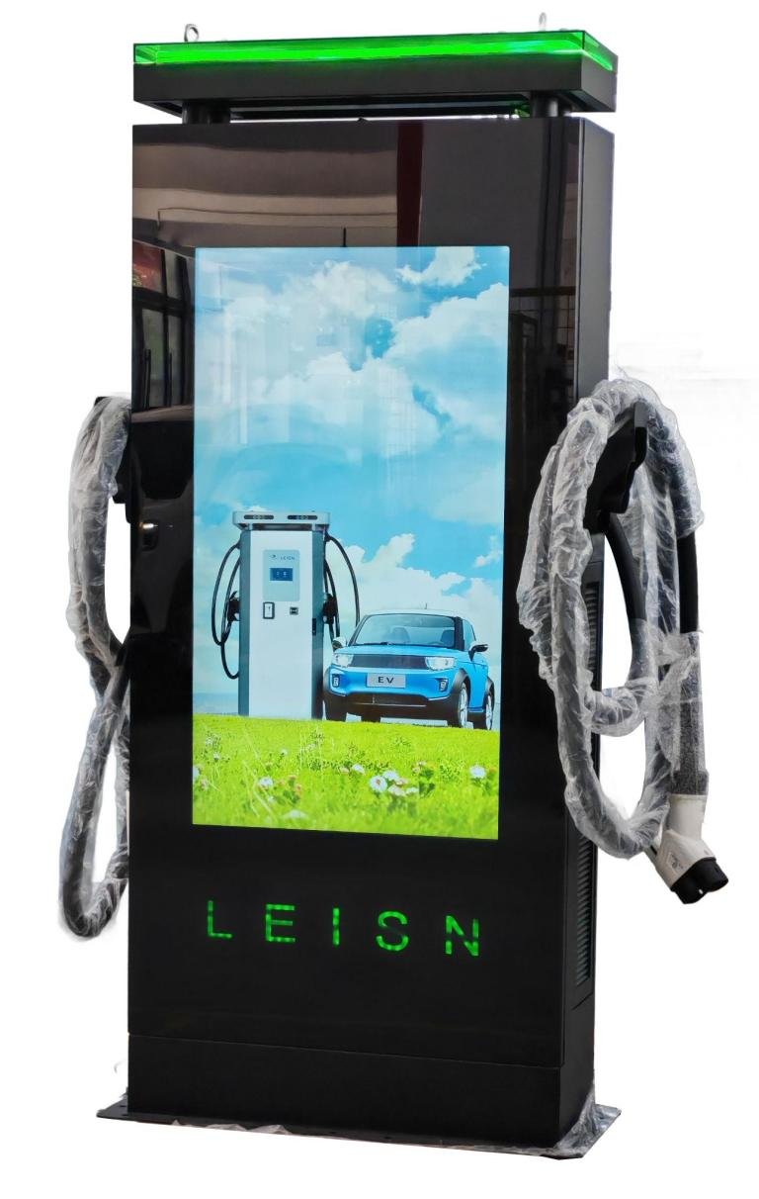

Content

1 Safety precautions 4

2 Product Overview 4

2.1. Product introduction 4

2.2. Packing list 5

2.3. Product characteristics 5

2.3.1. Main Functions 5

2.3.2. Protection Mechanism 6

2.3.3. Rich configuration 6

2.4. Technical specifications 6

2.5. Electrical schematic diagram of charging pile 8

3 30kW/ 40kW Charging module 9

4 Operation Guide 9

4.1 Indicator status 9

4.2 Charging Operation Procedure 10

4.3 Settings interface 11

4.4 Query interface 13

4.5 Attached table: failure description list 14

4.6 Operation precautions 14

5 Equipment transportation 15

6 Equipment installation 15

6.1 Electrical connection 17

7 Power on operation 18

8 HMI configuration mode of charger 18

9 Maintenance and after-sales 18

9.1. Troubleshooting 19

9.2. Quality assurance 21

9.3. Warranty conditions 21

10 Contact us 22

**Copyright**

The copyright of this User Manual belongs to Fujian Leisheng Energy Technology Co., Ltd. (hereinafter referred to as ‘LS’). Without the written permission of the Company, no unit or individual is allowed to extract or copy part or all of the contents of this document, and it is not allowed to disseminate it in any form (including materials and publications). This copyright belongs to Fujian Leisheng Energy Technology Co., Ltd., and any infringement shall be prosecuted.

Fujian Leisheng Energy Technology Co., Ltd. has the final right to interpret this user manual. If the product parameters change, the latest information of the company will prevail without notice!

Thank you for choosing the intelligent DC charging pile products of Fujian Leisheng Energy Technology Co., Ltd.!

LSDC series intelligent DC charging pile is a special DC power supply charging device for electric vehicles, which adopts professional power technology to provide efficient, safe and stable DC power supply for electric vehicles, and provides friendly human-computer operation interface. It has the corresponding functions of control, billing, communication and safety protection. It can connect to the background server, perfectly compatible with the OCPP standard protocol, and realize the mobile APP connection to achieve convenient functions such as reservation and online payment. Diversified communication modes are available, including wired Ethernet, WIFI and 4G wireless communications.

We sincerely hope that this product can meet your needs, and at the same time, we hope you can put forward more opinions on the performance and functions of the product. We will continue to improve the quality of our products.

# Safety precautions

● When using this product, please read the product manual carefully and operate in strict accordance with the steps in the product manual;

● If the product fault light is on or the screen indicates a fault, do not charge. Please refer to the solution in the product manual for troubleshooting or contact the equipment manufacturer for handling;

● Do not put flammable, explosive, combustible objects, chemicals and other dangerous goods near the charging pile;

● It is strictly prohibited to plug or unplug the charging gun during charging, and it is strictly prohibited to touch the inside of the charging plug to prevent electric shock;

● It is strictly forbidden to touch the charging plug or the charging socket of the electric vehicle. Keep the charging plug dry. Do not touch the charging plug with wet hands;

● Press the emergency stop button immediately in case of any abnormality during use;

● Do not attempt to disassemble, repair or modify the charging pile. Improper operation may cause damage, water leakage, electric leakage, etc;

● Please do not disassemble or repair the product without permission after it breaks down. Please contact professional after-sales personnel for handling;

● In case of rain and thunder, please charge carefully; If there is water at the bottom of the equipment or inside the charging plug head, it can be charged after the water is drained;

● Do not let children approach, touch or use the charging pile to avoid personal injury;

● Do not drive the vehicle during charging.

# Product Overview

## Product introduction

The integrated DC charging pile adopts the floor mounted design, with simple and generous appearance, stable frame design and complete protection functions; Applicable to bus charging stations, residential areas, industrial parks, high-speed service areas, parking lots and other types of charging places; The rated power of the whole equipment can be flexibly configured, and the output power can be automatically adjusted with the load. It is efficient charging equipment that provides power supply for new energy vehicles with DC charging ports meeting European standards.

## Packing list

|  |  |  |  |
| --- | --- | --- | --- |
| Number | Name | Quantity | Remark |
| 1 | Battery charger | 1 |  |
| 2 | User Manual | 1 |  |
| 3 | Test Report | 1 |  |
| 4 | Certificate of conformity | 1 |  |
| 5 | RFID Charging Card | 3 |  |
| 6 | Inner explosive expansion bolt at outer hexagon  M10*70/GB 5783-86, 304 stainless steel | 4 |  |

## Product characteristics

#### Main Functions

* **High Power Output:** With a power output of 120KW, it can quickly charge electric vehicles, significantly reducing charging time and improving efficiency.
* **Dual-Gun Design:** Allows simultaneous charging of two electric vehicles, increasing the utilization of the charging station and meeting the demand for multiple vehicle charging.
* **DC Charging:** Adopts DC charging method, enabling faster energy transfer to the vehicle's battery, reducing waiting time.
* **High Stability:** Utilizes advanced technology and reliable components to ensure stable charging and reduce the likelihood of malfunctions.
* **Intelligent Control:** Equipped with an intelligent charging management system that automatically adjusts the charging current and voltage based on the vehicle's battery status and needs, protecting battery life.
* **Safety and Reliability:** Includes multiple safety protection mechanisms such as overload protection, short circuit protection, overvoltage protection, and undervoltage protection to ensure a safe charging process.
* **Easy Installation:** Simple and convenient installation, suitable for various locations such as parking lots and gas stations.

Additionally, the 80KW DC charging station is widely compatible, capable of charging different brands and models of electric vehicles. It is ideal for various scenarios, including highway service areas, urban public charging stations, large parking lots, and shopping centers. It can quickly recharge vehicles, ensuring smooth journeys and meeting daily travel and temporary charging needs.

#### Protection Mechanism

* It has perfect charging protection function to prevent the vehicle from overcharging, with high safety;
* It has protection mechanisms such as phase loss, lightning protection, abnormal protective grounding, short circuit, overcurrent, over temperature, insulation fault, battery reverse connection, etc;
* It has the protection functions of input overvoltage, undervoltage, abnormal connection, emergency stop, communication failure, etc;
* With insulation detection function, charging is prohibited when the insulation performance drops to ensure charging safety.

#### Rich configuration

* Modular design: it is compatible with different charging modules, adapt to various levels of voltage and current, and all protection functions can be switched on and off independently;
* Flexible charging mode: you can select charging modes such as time, amount, power, automatic charging, reservation and power;
* Various charging methods: offline card start charging, online card start charging, code scanning start charging, password start charging and other charging methods can be selected;
* Convenient and selective platform communication: multiple networking modes are available, including RS485/232 bus, Ethernet, CAN bus, 4G, etc

## Technical specifications

|  |  |  |
| --- | --- | --- |
| Name | | LSDC80S1101 |
| Size（mm） | | 850x300x2000mm |
| Weight（KG） | | 236.6KGs |
| Screen Material | | LCD |
| Shell Material | | Sheet Metal |
| AC Input | | |
| System | | L1，L2，L3，N，PE |
| Voltage | | 260V-530V |
| Frequency | | 45～65HZ |
| DC Output | | |
| Voltage | | DC150V～1000V |
| Current | | GBT：200A  CCS1/CCS2:200A  CHAdeMO:150A |
| Voltage stabilization accuracy | | ＜±0.5% |
| Current stabilization accuracy | | ≤±1％（Output load 20％～100％ Rated range） |
| Power factor | | Power factor ≥0.95 @25％～50％Full load output power  ≥0.98 @50％～100％Full load output power  ≥0.99 @100％Full load output power, Nominal input voltage and frequency |
| Efficiency | | Efficiency ≥95％，@1000V，50％～100％Load current, under rated three-phase input voltage |
| IP Degree of protection | | IP55 |
| Operating ambient temperature | | －40℃～70℃ |
| Relative humidity | | ≤95%RH, no condensation |
| Altitude | | ≤2000 meters，Derating for use above 2000 meters |
| Cooling mode | | Forced air cooling |
| Remote monitoring mode | | Ethernet / 4G/WIFI (Optional ) |
| Startup mode | | RFID/APP |
| Standby power | | 25W(Excluding advertising television sets) |
| Charging standard | | IEC-62196-2;EN61851 |
| Installation method | | Wall mounted / Floor mounted |
| authentication | | CE |
| Metering accuracy | | 0.5 |
| Safety protection function | | |
| Input Overvoltage Protection | | ≥530Vac |
| Input undervoltage protection | | ≤260Vac |
| Over temperature protection | | Derating above 55 ℃; 75 ℃ protection shutdown |
| Short circuit protection | | Yes |
| Emergency stop protection | | Yes |
| Leakage protection | | Type A |
| Lightning protection | | Level 2 lightning protection standard |
| Cable Management Details | | |
|  | * Resolution: 1920x1080 * Dimensions: 1098*630*50 mm * Brightness: 500 nits * Contrast Ratio: 1200:1 * Response Time: 6ms (GTG) * Panel Refresh Rate: 60Hz * Lifespan: 50,000 Hours * Graphics Processor: Mali-G31 MP2 * RAM: 2GB * Storage: 32GB * Operating System: Android 9.0 * UI Language: Chinese/English | |

## Electrical schematic diagram of charging pile

# 30kW/ 40kW Charging module

It is already set up before leaving the factory and no additional operation is required.



Note: The dialing code is in binary 8421 code form, the right side is low bit (the number 6 below the dialing diagram corresponds to the lowest bit), and the left side is high bit (the number 1 below the dialing diagram corresponds to the highest bit). When the code is dialed downward, indicating 0; when the dial code is dialed upward, indicating 1.

The module state indicator instruction is shown as table 1.

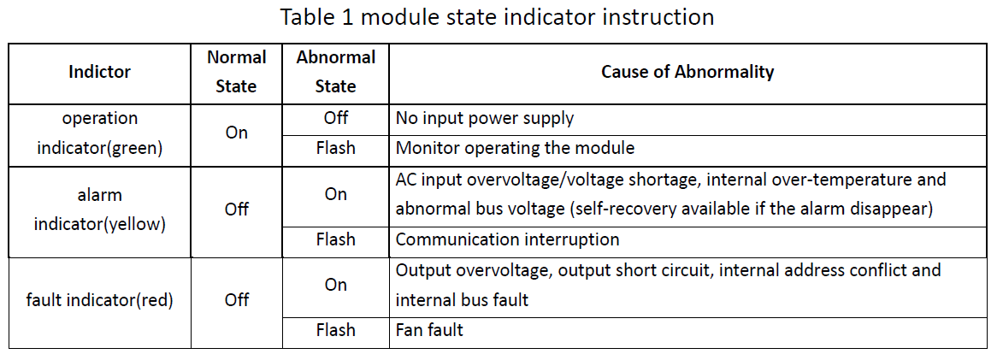

# Operation Guide

## 4.1 Indicator status

The 3 colors of indicators represent the different states of the charging pile.

|  |  |  |  |
| --- | --- | --- | --- |
| **No** | **Indicator definition** | **Colour** | **Function** |
| 1 | POWER | Yellow | Normally on: working state |
| 2 | CHARGE | Green | Flashing: charging gun is connected and ready for charging |
| Always on: charging state |
| Normally off: charging is completed or the gun is not inserted, in standby mode |
| 3 | FAULT | Red | Always on: equipment alarm or fault status |

## 4.2 Charging Operation Procedure

|  |  |
| --- | --- |
| Charging pile standby |  |
| The charging cable is connected |  |
| Select the charging method |  |
| Charging interface |  |
| Detail |  |
|  |
| Bill |  |
| Failure interface |  |

## 4.3 Settings interface

|  |  |
| --- | --- |
| Enter the password：77777777，Go to settings |  |
| Main interface |  |
| CCU |  |
| PCU |  |
| OCPP |  |
| Rate settings |  |

## 4.4 Query interface

|  |  |
| --- | --- |
| Charging record query |  |
| Fault record query |  |
| Password charging query |  |

## 4.5 Attached table: failure description list

|  |  |
| --- | --- |
| **NUM** | **Definition description** |
| 1 | Emergency stop is pressed! |
| 2 | RFID communication fault! |
| 3 | Over temperature fault! |
| 4 | Lightning protection fault! |
| 5 | Power module communication fault! |
| 6 | Meter communication fault! |
| 7 | DC output overvoltage fault! |
| 8 | DC output overcurrent fault! |
| 9 | Waiting for BMS communication timeout! |
| 10 | Insulation detection timeout! |
| 11 | Insulation detection fault! |
| 12 | Battery voltage reverse fault! |
| 13 | DC+ Contactor sticking fault! |
| 14 | DC- Contactor sticking fault! |
| 15 | Plug line disconnection fault! |
| 16 | Plug head connection over temperature fault! |
| 17 | AC Contactor sticking fault! |
| 18 | AC Input Overvoltage! |
| 19 | AC Input Undervoltage! |
| 20 | BMS communication fault! |

## 4.6 Operation precautions

* If the screen display device fails or the power light does not light, please do not charge, please contact the staff;
* When using the equipment, please operate according to the relevant prompts in the charging pile or product manual;
* Pay attention to the strength when unplugging the charging plug, and do not forcibly unplug it;
* It is prohibited to draw the plug with electricity during charging to prevent personal and property injuries;
* In case of emergency, please press the emergency stop switch, and the charging pile will stop charging immediately;
* In case of thunderstorm, please stop charging.

# Equipment transportation

* Under any circumstances, do not disassemble or modify the equipment without permission. Any failure caused by unauthorized disassembly is not within the warranty scope;
* Please do not transport with damaged package or without package;
* Please operate according to the transportation precautions on the packaging silk screen;
* Do not dump the equipment during transportation;
* Please avoid excessive turbulence and impact during transportation;
* Please take corresponding protective measures when transporting in bad weather.

# Equipment installation

After receiving the equipment, please make an unpacking inspection record and check whether the data and accessories are complete according to the installation list. If there is any discrepancy, please contact the supplier in time. After unpacking, check whether the equipment appearance is damaged or abnormal. If there is any problem, make a record and contact the supplier in time.

**Installation preparation**

**Cable preparation**

Recommended cable specifications for power supply are as follows：

|  |  |  |
| --- | --- | --- |
| The power of the charger | Recommended incoming cable model | Note |
| 120kW | 3*95mm²+2*70mm² | L1，L2，L3 ，N，PE |
| 150kW | 3*120mm²+2*70mm² | L1，L2，L3，N，PE |
| 180kW | 3*150mm²+2*95mm² | L1，L2，L3，N，PE |
| 240kW | 3*185mm²+2*95mm² | L1，L2，L3，N，PE |

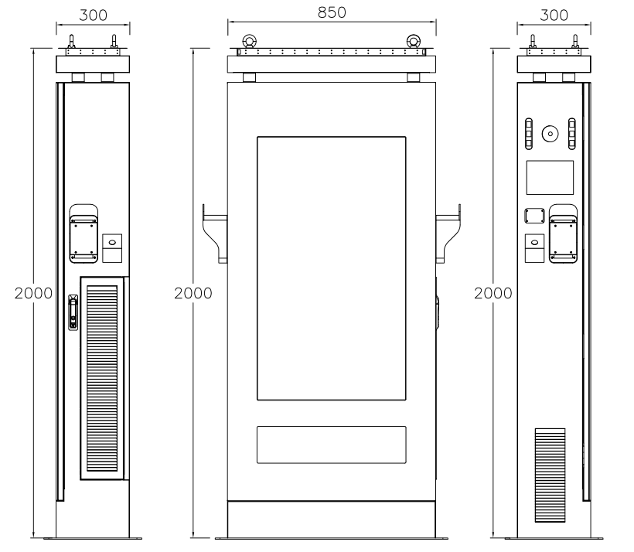

1. The DC electric vehicle charging station has a front-opening door, and space should be reserved around it for operation. The reserved space dimensions are shown in the diagram below.
2. It is recommended to install the cabinet on a concrete or channel steel foundation. The base hole dimensions are shown in the diagram below.
3. Pre-embed the cables in advance, and leave a cable length of 1 meter from the foundation.
4. The recommended foundation height is 200mm (too high would be inconvenient for operation and maintenance). The installation vertical inclination should not exceed 5%.
5. The customer needs to reserve the installation holes according to this size on the installation platform in advance, align the holes according to this size after the arrival of the equipment, and then fix them with 4 M12 expansion bolts.

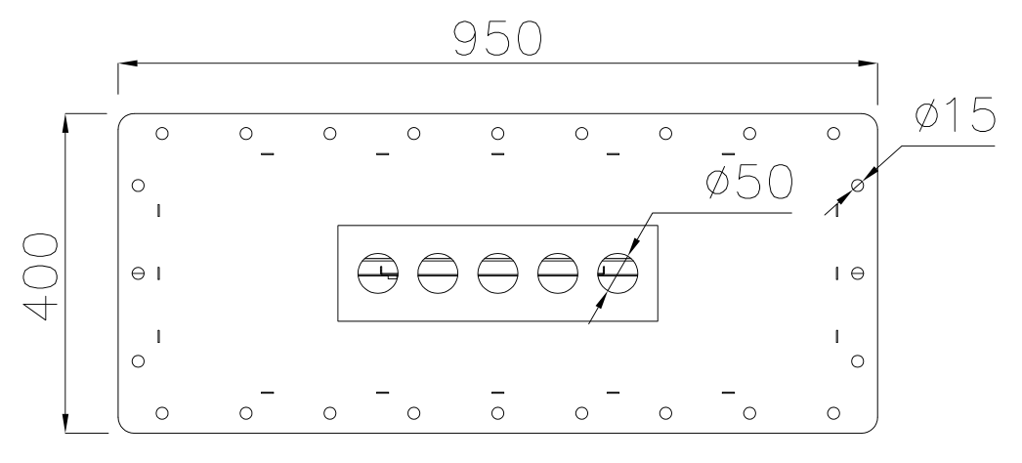  
 Base hole drawing

1. Place the equipment on the cement base and secure it with screws.
2. Connect the distribution cables.
3. Seal with sealing clay.
4. Clean up debris inside and around the cabinet, such as small cable segments, ties, screws/nuts, etc. Do not leave installation tools on-site or inside the cabinet (record the types and quantities of tools to prevent any from being left behind).
5. Check if the base is fixed and sealed, ensure the internal components of the equipment are secure, the electrical connections and wiring are correct and complete, and the connections are firm. Verify the grounding is reliable, and check the appearance, labeling, integrity, and cleanliness.

## 6.1 Electrical connection

Input cable: 3*16mm²+2*10mm²

|  |  |  |
| --- | --- | --- |
| **Wiring name** | **Electric wire diameter** | **Connection location** |
| L1/A | 35mm² | Connect to MCB |
| L2/B | 35mm² | Connect to MCB |
| L3/C | 35mm² | Connect to MCB |
| N | 35mm² | Connect to MCB |
| PE | 35mm² | Connect to sheet metal internal ground stud |
|  |  |  |

|  |  |
| --- | --- |
| The system wiring is three-phase five wire system. Connect the input line to the input terminal and the ground bar according to the system wiring diagram. During wiring, ensure that the circuit breaker at the power supply end and all circuit breakers in the cabinet are in the disconnected position.  Shown in Figure  Check the upper left corner of the display, no fault codes are displayed. If a fault code is displayed, please contact the manufacturer immediately. | 1745490640629 |
| * ➢Check whether the internal fasteners are loose and whether the electrical components are intact. * ➢Whether the system is well grounded, and all switches are in the off position. * ➢Use a multimeter to measure whether the input power is 260V-530V. * ➢Close AC circuit breaker, air switch. * ➢The inspection indicator light should only have a blue light on. * ➢There is no fault code in the upper left corner of the display. | |

# Power on operation

* ➢Check whether the internal fasteners are loose and whether the electrical components are intact.
* ➢Whether the system is well grounded, and all switches are in the off position.
* ➢Use a multimeter to measure whether the input power is 260V-530V.
* ➢Close AC circuit breaker, air switch.
* ➢The inspection indicator light should only have a blue light on.
* ➢There is no fault code in the upper left corner of the display.

# HMI configuration mode of charger

The charger is already configured at the factory and can be used without special configuration

# Maintenance and after-sales

Due to the influence of ambient temperature, humidity, dust and vibration, the components inside the charging pile will be aged and worn, which will lead to the potential failure of the charging pile. Therefore, it is necessary to carry out daily and regular maintenance on the charging pile to ensure its normal operation and service life.



* Only professional electricians or personnel with professional qualifications can operate;
* During equipment maintenance and repair, be sure to cut off the incoming power supply, test all voltage and high temperature components, and confirm safety before operation;
* During equipment maintenance, necessary protective measures shall be taken to prevent equipment from being powered on by mistake, clear maintenance marks shall be set, and isolation and protection measures shall be taken for live parts;
* Carry out maintenance work, do not leave screws, washers and other metal parts in the charging pile, and conduct a comprehensive inspection on the chassis after maintenance.

The charging gun shall be put back after use and inserted into the gun seat in front of the cabinet to prevent rainwater from entering.

Chargers without background management system need regular on-site maintenance.

The dust-proof cotton shall be disassembled and cleaned after 6 months of system operation, and shall be installed and used after being dried. If the dust-proof cotton is not cleaned for a long time, it will cause difficulty in air inlet, increase the module load, and easily cause module damage.

|  |  |  |
| --- | --- | --- |
| **Maintenance object** | **job content(Every 3 months)** | **job content(Once a year)** |
| Cleaning of cabinet  (External and internal base plates) | Check for dust and dirt | / |
| Terminal blocks | Check for dust and dirt | Check dust and dirt; Insulation and fastening |
| Wiring cable | Check for dust and dirt | Check dust and dirt; Insulation and fastening |
| Air outlet filter screen | Check the dust accumulation and replace the filter screen according to the operating conditions of the equipment | / |
| Component fastening | ­­/ | Check for looseness |
| Equipment function inspection | / | Charging control functions include man-machine interface, electrical control, safety protection, etc |

## Troubleshooting

Note: Common faults include user operation and equipment abnormality.

Only professional electricians or personnel with professional qualifications can operate the contents of this chapter.

|  |  |  |  |
| --- | --- | --- | --- |
|  | Fault phenomenon | Cause of failure | Treatment measures |
| User Action | No reaction when inserting the gun | The charging gun is not plugged in properly | Reinsert the plug |
| Vehicle ACC is not turned on or off (different vehicles have different phenomena)  equipment failure | Turn vehicle ACC off or on |
| equipment failure | Contact staff |
| Low charging current | Vehicle SOC is large | Normal |
| Low ambient temperature, battery protection | Current recovery after preheating for a period of time |
| Emergency stop is pressed | The emergency stop switch is pressed by mistake | Release the emergency stop switch |
| No response when swiping the card | The emergency stop switch is pressed by mistake | Align the card swiping area |
| The charging card is too far away | The charging card is close to the card swiping area |
| equipment failure | Contact staff |
| Abnormal charging start | BMS voltage setting error | Set according to vehicle model |
| Abnormal vehicle battery voltage | Voltage mismatch, unable to charge |
| equipment failure | Contact staff |

|  |  |  |  |
| --- | --- | --- | --- |
| Equipment abnormality | Background communication failure | Network fault or poor signal | Network troubleshooting |
| Insufficient traffic or network arrears | Charging |
| Input overvoltage/  undervoltage output overcurrent | Grid anomaly | Check the grid voltage |
| Error in setting parameter threshold | Check the setting parameters |
| Charging module failure | The charging module is loose or the connecting wire is loose | Re-insert the module and check the connecting line at the end of the module |
| The charging module is damaged | Replace the charging module |
| Fan does not turn | The temperature does not reach the set value | Check whether the temperature sensor is abnormal |

## Quality assurance

**Warranty**

The warranty period of this product is 1 year. If otherwise specified in the contract, the contract shall prevail.

During the warranty period of the products of Fujian Leisheng Energy Technology Co., Ltd., the customer shall take the initiative to show the invoice and date of purchase of the products to the service personnel of Fujian Leisheng Energy Technology Co., Ltd. during maintenance. At the same time, the nameplate identification on the product shall be clear and visible, otherwise, it has the right not to repair.

## Warranty conditions

In case of any product failure during the warranty period, Fujian Leisheng Energy Technology Co., Ltd. will repair or replace the product free of charge. The replaced faulty machine shall be owned by Fujian Leisheng Energy Technology Co., Ltd. The customer shall reserve a certain time for Fujian Leisheng Energy Technology Co., Ltd. to repair the faulty machine.

**Exemption from liability**

The Company has the right not to provide quality assurance in the following cases:

* Products without the logo of Fujian Leisheng Energy Technology Co., Ltd.;
* Products or parts have exceeded the warranty period of Fujian Leisheng Energy Technology Co., Ltd.;
* Those who fail to comply with the requirements of the manual, and are not caused by the working environment specified by the product or incorrect installation, storage and use (such as too high and too low temperature, too wet or dry, too high altitude, unstable voltage or current, etc.);
* Failure or damage caused by installation, repair, change or disassembly of after-sales service personnel other than Fujian Leisheng Energy Technology Co., Ltd., except those entrusted by Fujian Leisheng Energy Technology Co., Ltd.; Failure or damage caused by using non Fujian Leisheng Energy Technology Co., Ltd. components;
* Failure or damage caused by accident or human factors (operation error, scratch, handling, bump, access to inappropriate voltage, etc.), transportation damage;
* Those caused by natural disasters and other force majeure (such as earthquake, lightning strike, fire, etc.);
* Other failures or damages not caused by the quality problems of machines (including parts) of Fujian Leisheng Energy Technology Co., Ltd..

**Statement of responsibility**

The copyright of this manual belongs to Fujian Leisheng Energy Technology Co., Ltd.. Without the written permission of the company, any unit or individual shall not extract or copy part or all of the contents of this manual, and shall not disseminate it in any form (including materials and publications). Fujian Leisheng Energy Technology Co., Ltd. has the final right to interpret this manual, and any infringement shall be prosecuted. Due to the continuous upgrading of the product, the contents of this manual will be constantly modified and adjusted without notice.

# Contact us

* Fujian Leisheng Energy Technology Co., Ltd.
* Tel-phone:0086-0591-87869992
* Email: [info@leisnenergy.com](mailto:info@leisnenergy.com)
* Address:Building 1, Area B, No. 36 Chitang Road, Shangjie Town,Minhou County, Fujian Province, China