Dual gun/socket AC ground charging pile series

**User manual**

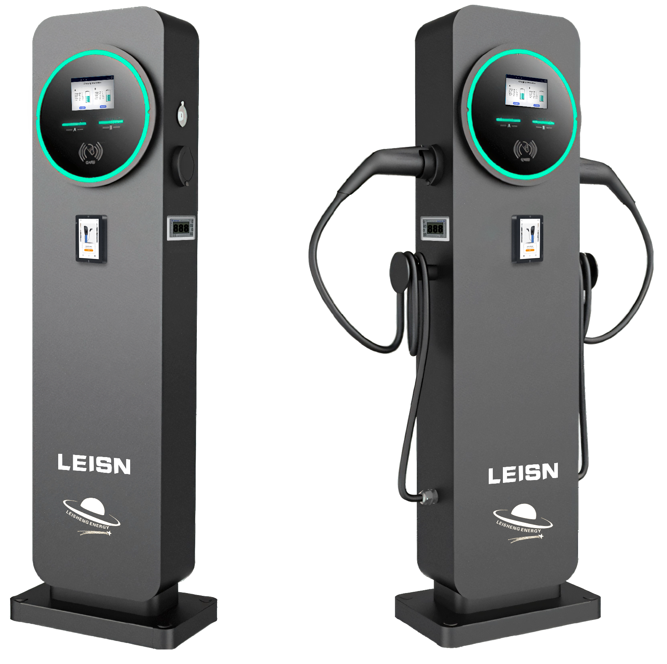

Version: V1.0

**CONTENT**

**1 Warranty**

**2 Safety and Warning**

**3 Introduction**

3.1 Product Technical Specifications 3.2 External Structure

3.3 Package Contents

**4 Configuration and Operation**

4.1 Power-on Checking

4.2 Start and stop charging station

4.3 Server URL and Network configuration

4.3 Start and stop charging station

**5 Set up and update**

5.1 Mode setting for maximum charging current

5.2 Firmware version upgrade(by SD card)

5.3 Firmware version upgrade(by online)

**6 Troubleshooting**

6.1 Indicator Status

6.2 Fault Code and Resolution(LCD display)

**Warranty**

Fujian Leisheng Energy Technology Co., Ltd (Hereinafter “LEISHENG ENERGY”) warrants that Products supplied to Customer pursuant to this Agreement/Contract shall be of merchantable quality and shall meet all applicable safety standards and free from any defect of design, material and workmanship within the warranty period. The warranty period is Twenty-four (24) months since from the delivery date. YingLi warranty does not cover damages resulting from inappropriate storage, incorrect installation, improper operation or bad environment beyond environmental requirement.

Customer gives notice in writing within a period of ten (10) days after Customer has discovered that some or all Products do not comply with the warranty as set out in this warranty. Customer shall provide necessary assistance to LEISHENG ENERGY for failure detection. LEISHENG ENERGY gives response within a reasonable time of 48 hours. LEISHENG ENERGY shall analyze the fault reason and provide technical instruction for Customer to repair Products.

Customer repairs Products and applies for free spare parts from YingLi in case

replacements are required. A written claim report about fault description, serial number of Products, photos of Products and applied spare parts must be sent to YingLi for verification. LEISHENG ENERGY shall not accept the claim if modifications or reworking have been performed to Products without YingLi’s consent. Spare parts are offered for free within the warranty period. Beyond warranty period, spare parts are offered at Customer’s cost.

Faulted parts replaced by Customer shall be well stored and packaged with markings of fault description for further disposal by LEISHENG ENERGY . The faulted parts after repair and test can be treated as spare part to Customer.

Local services are not provided free of charge unless agreed with both parties prior to the provision of local services

Except as set forth herein, LEISHENG ENERGY provides no other warranty, whether express or implied. The warranty applies only to Products which are supplied by LEISHENG ENERGY and are used out of Mainland China.

**1 Safety and Warning**

Save these instructions. Read all instruction before installing or using the charger.

1）Keep the charger away from explosive or flammable materials, chemicals, vapors and other hazard objects.

2）Keep the charger socket clean and dry. If it gets dirty, please wipe it with clean dry cloth. 3）Touching the socket core is strictly forbidden when power on.

4）Do not use the charger in case of any device defects, crack, abrasion, bare leakage and so on. Please contact the professional personnel if any of these conditions occurs.

5）Do not attempt to dissemble, repair, refit the charger. If necessary, please contact the

professional personnel. Improper operation will result in device damage, electric leakage, etc. 6）In case any abnormal condition happens, please cutoff all input and output power supplies immediately.

7）Please protect charging carefully from rain and lightening.

8）Keep children away from the charger.

9）During charging, do not drive the EV Charge only when the EV is stationary,for hybrid cars, charge only when the engine is switched off.

10) Our packaging materials are environmentally friendly and can be recycled. Please put the packaging in applicable containers to recycle it. Do not dispose of this device with the

household waste. It should be taken to a suitable facility for recycling of electrical and

electronic devices. For more detailed information about recycling of this device, please contact your local city/town council office or your household waste disposal service.

|  |
| --- |
| The input and output voltages of this device are high voltage, which  threaten human life safety. Please strictly observe all warnings on the  device and user manual. Unauthorized and non-professional service  personnel are forbidden to remove the cover of this device. |

**2 Introduction**

**2.1 Product Technical Specifications**

|  |  |  |  |  |  |
| --- | --- | --- | --- | --- | --- |
|  | Datasheet | model | LS-EVS-14-11222 | LS-EVS-22-11222 | LS-EVS-44-11222 |
| 双枪落地交流充电桩 | Input | Power Supply | 1P+N+PE | 3P+N+PE | 3P+N+PE |
| Rate Voltage | 230V AC | 400V AC | 400V AC |
| Rate Current | 32A | 16A | 32A |
| Frequency | 50/60Hz | 50/60Hz | 50/60Hz |
| Output | Output Voltage | 230V AC | 400V AC | 400V AC |
| Maximum Current | 32A | 16A | 32A |
| Rated Power | 7kW+7KW | 11kW+11kW | 22kW+22kW |
| User Interface | LED Indicator | Green/Yellow/Red | | |
| LCD Display | 5.0inch | | |
| RFID | Mifare ISO/IEC 14443 A | | |
| Charge Mode | Plug&Charge 、RFID 、 App | | |
| Emergency Stop | Yes | | |
| Communication | WiFi | optional | | |
| Ethernet | Yes | | |
| 4G | optional | | |
|  | OCPP | OCPP 1.6 J | OCPP 1.6 J | OCPP 1.6 J |
|  | Energy Meter | Mid Meter | Mid Meter | Mid Meter |
| Safety | RCD | 30mA Type A + 6mA DC | | |
|  | Ingress Protection | IP54 | | |
|  | Impact Protection | IK08 | | |
|  |  | Electrical Protection | Over current , Residual current , Short circuit , Ground, Lightning , Over/Under voltage , Over/Under frequency , Over temperature | | |
|  |  | Certification | CE | CE | CE |
|  |  | Certification Standard | EN/IEC 61851-1: 2017, EN/IEC 61851-21-2: 2018 | | |
|  |  | Warranty | 2 years | 2 years | 2 years |
|  |  | Installation | Floor type | Floor type | Floor type |
|  | Environment | Work Temperature | -30℃~+50℃ | -30℃~+50℃ | -30℃~+50℃ |
|  | Work Humidity | 5%~95% | 5%~95% | 5%~95% |
|  | Work Altitude | <2000m | <2000m | <2000m |
|  | Package | Product Dimension | 1400mm*350mm*160mm | | |
|  | Package Dimension | 1611*328*523mm | | |
|  | Net Weight | 28kg | 30kg | 34kg |
|  | Gross Weight | 46kg | 48kg | 51kg |
|  | External Package | Wooden box | Wooden box | Wooden box |

**2.2 External Structure**



1400mm*350mm*160mm

**2.3 Package Contents**

Unpack the product. Please check and verify following items after receiving the charger :

 Visual inspection on charger’s external appearance. If there is any breakage or other damage,please notify the seller immediately.

 Check type and quantity of all accessories as follows. If there is a shortage in the quantity of any item or if any items are missing, please contact the seller at once.

|  |  |  |  |  |
| --- | --- | --- | --- | --- |
| 双枪落地交流充电桩 |  |  |  |  |
| User Manual  (x1) |  | M8 Screw nut  (x4) |  |
|  |  |  |  |
| Charger(x1) |  | RFID CARD (x2) | Key (x2) | SD card(x1) |

**3 Operation Instruction**

**3.1 Installation Preparation**

1) Tools required

|  |  |  |
| --- | --- | --- |
| **Tool Name** | **Photo** | **Function** |
| Multimeter |  | Check electrical  connection  and electrical parameter |

|  |  |  |
| --- | --- | --- |
| Cross Screwdriver  (PH2x150mm,  PH3x250mm) |  | Tighten the screws |
| Insulated Torque Wrench |  | Tighten the bolts |
| Electric drill |  | Hole on the wall |
| Diagonal Pliers |  | Cut cables |

2) Cables & Materials

|  |  |  |
| --- | --- | --- |
| **Name** | **Specification** | **Quantity** |
| Power supply cable(7kw+7kw) | 3*12MM² | 1 |
| Power supply cable(11kw+11kw) | 5*6MM² | 1 |
| Power supply cable(22kw+22kw) | 5*12MM² | 1 |

**3.2 Installation Process**

**1) Installation Notice**

 Electrical devices should only be installed, operated, and maintained by qualified

personnel. No responsibility is assumed by the manufacturer for any consequences

arising out of the use of this device. A qualified person is one who has certified skills and knowledge related to the construction, installation and operation of this type of electrical

device and who has received safety training to recognize and avoid the hazards involved.

 All applicable local, regional, and national regulations must be applied when installing, repairing and maintaining this device.

 RCD of the charger is intergrated 6mA DC, please install a Type A breaker outside.

**2) Checks before starting the Installation Process**

 Ensure the charger’s location allows good operational access for normal use and repair & maintenance.

 The AC input components within the premise’s power supply are correctly fitted with required protection items prior to installation of the charger.

**3) Installation Foundation**

1. Fix the foundation pier by pouring cement，

2. Before completing the above steps, the input cable needs to be pre-buried below

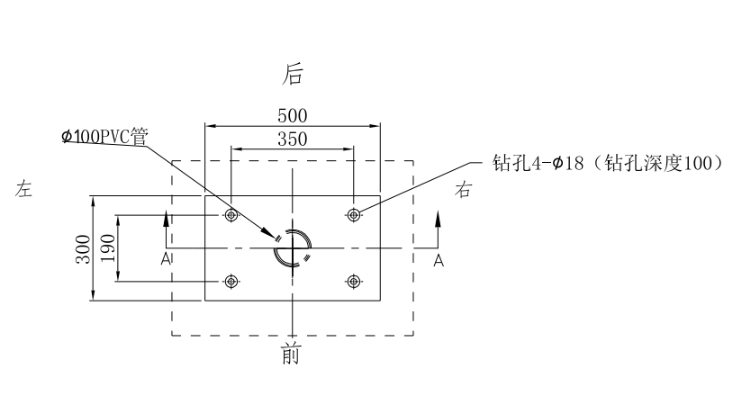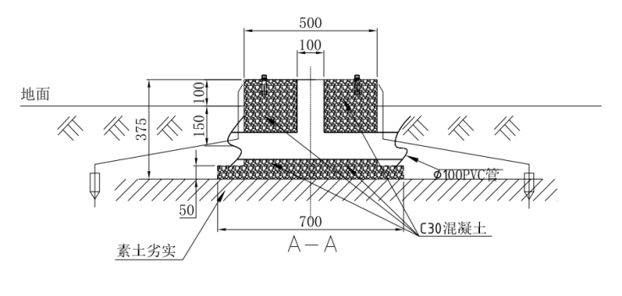

3.Fix the charging pile with screws(4*M8), and the input wire is connected to the input terminal of the charging pile

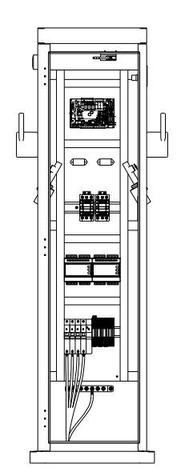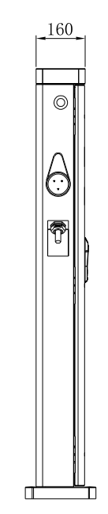

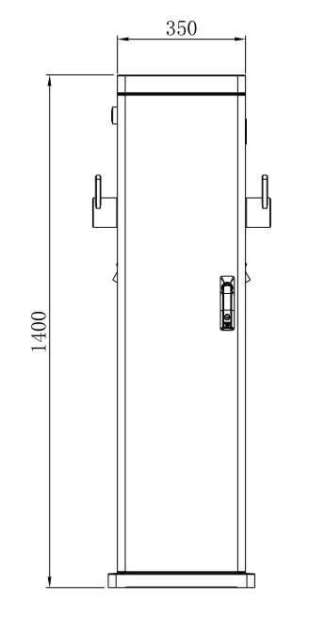

**4.OPERATION**

**4.1Power on**

After the charging station has been installed and installation has been confirmed, the charging station switches to standby state, The display is shown in fig. 4-1.

Human-Machine Interface Overview

As shown in Fig. 4-1, the EMN series product is configured with multiple human- machine interfaces

31393935333439393b363139323738303b5e8f53f73431393935333439393b363139333639333b5e8f53f73631393935333439393b363139333231313b5e8f53f735**31393935333439393b363139323135333b5e8f53f73131393935333439393b363139323634383b5e8f53f732**31393935333439393b363139323635333b5e8f53f733.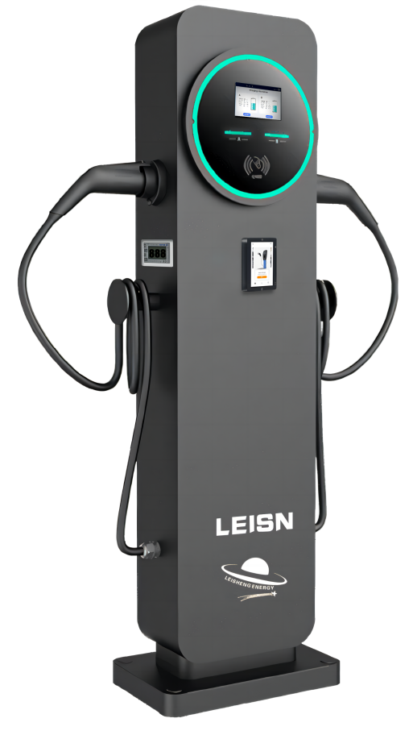

1 LCD Display 3 RFID 5 Mid meter (optional)

2 LED 4 Type 2 GUN*2 6 Pos machine(optional)

**Fig. 4-1 HMI of AC EV Charging Station**

**4.2 RGB LED indicators**

|  |  |
| --- | --- |
| Charger status | LED performance |
| Standby | blue (online) |
| plug in | yellow |
| swipe/punch a card | yellow |
| charging | Light green breath |
| Fault status | Red flashing |

**4.3 LCD indicators**

the charger config a 5-inch Touch LCD screen, which is mainly used to display various status information of the charging station, shown as Fig. 4-2.

. **Icons or instructions in each display area**

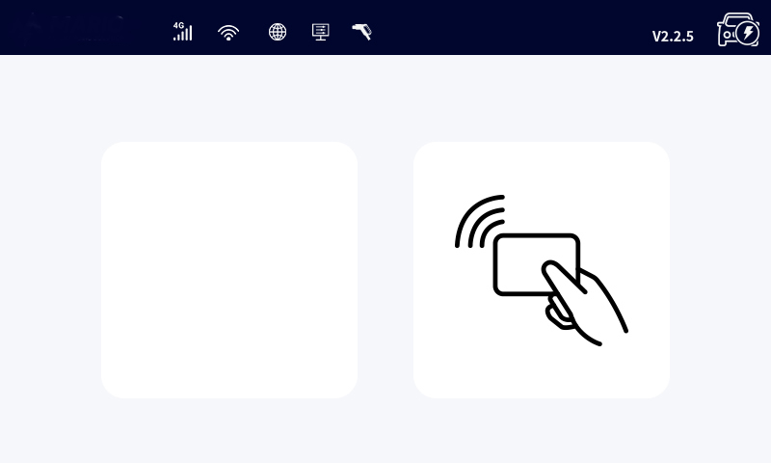

**Fig. 4-2 Display of icons and instructions**

In Fig. 4-2, there are three areas to display icons or instructions, with the specific meanings as follows:

|  |  |  |
| --- | --- | --- |
| **No.**  **Area** ①  1 | **Icon** | **Description**  Connected a network through 4G cellular |
| 2 |  | Connected a network through WIFI |
| 3 | 3 | Connected a network through Ethernet |
| **Area** ② | | |
| 4 QR code Serial number of EVSE | | |
| **Area** ③ | | |
| 5 | status | EVSE status information |
| 6 | version | Software version |

. As shown in Fig. 4-3,4-4,4-5, the LCD screen displays 3 types picture in normal state.

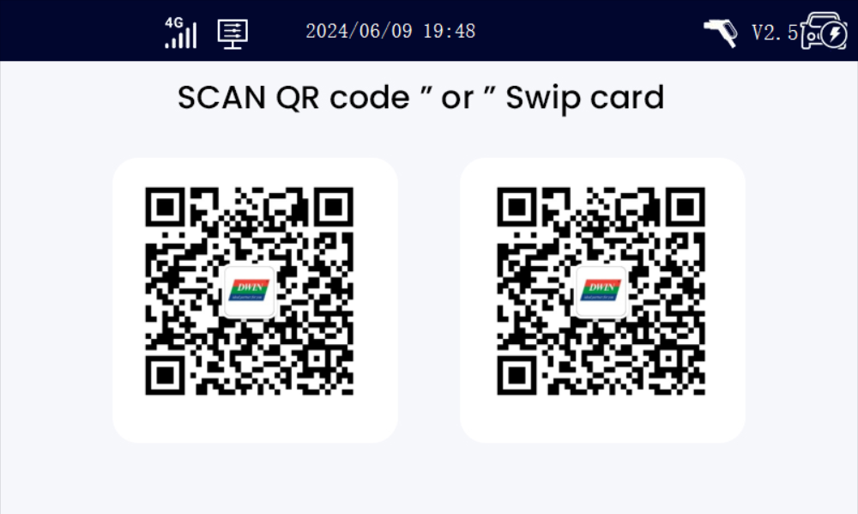

**Fig. 4-3** Display of Avaliable

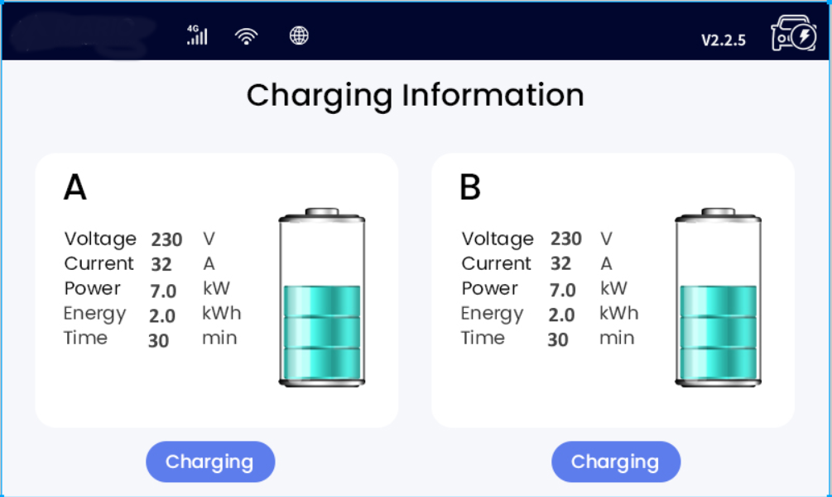

**Fig. 4-4** Display of Charging

If the charging process fails or the equipment fails, the picture displayed on the LCD

screen is shown in Fig4-4

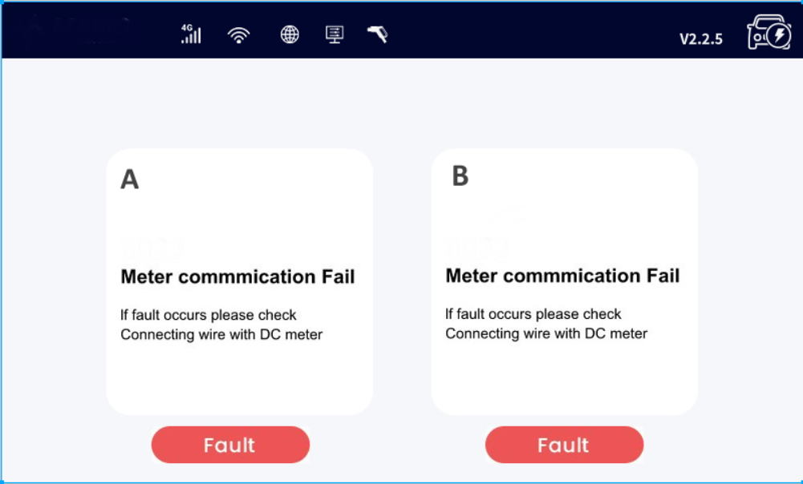

**Fig.4-5 Display of fault state**

**4.4 RFID reader**

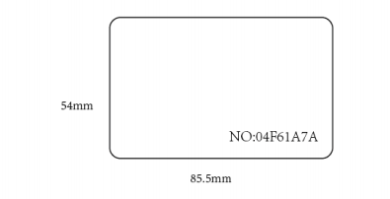

**Fig. 4-5 RFID card**

In general, the charging station is equipped with RFID card reader as

standard, and the charging process can be started and stopped by using the RFID card (shown as Fig. 4-5) configured with the host. The special

customized card swiping function is not separately described here

**4.5 Emergency stop button**

The button can stop or start charging after the device is configured to allow the button to start, The user can configure whether the function is enabled. See the 6.3 Configure parameters for details AC EV charging station config a type 2

charging connector. When the charging station is in standby state, please plug the charging connector into the empty socket in order to protect the charging connector.

**4.6 Configure parameters**

4.6.1 Model and meter Settings

1. Machine The type of the configuration machine can be set according to the actual accessories 7kw+7kw ,11kw+11kw ,22kw+22kw
2. Meassure meter Can be set
3. Meassure meter address Can be set

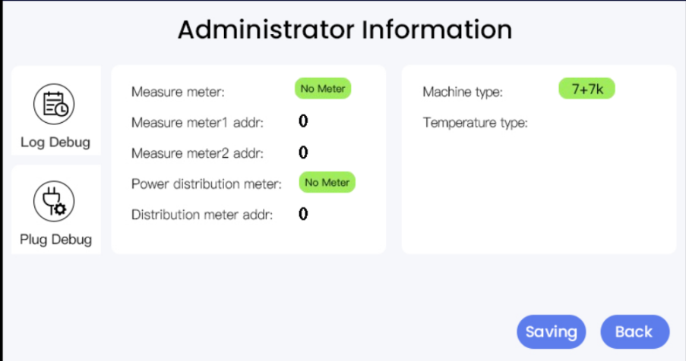

**Fig. 4-6**

4.6.2 Set network（4G,WIFI,LAN） parameters

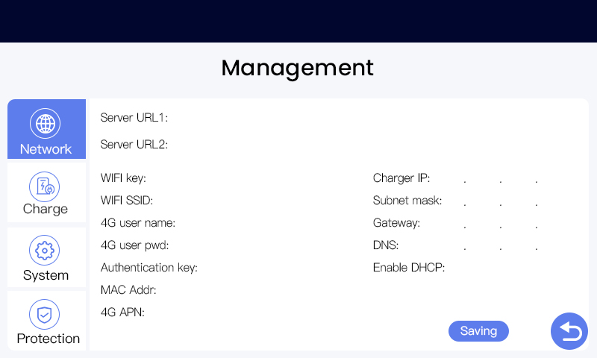

**Fig. 4-7**

4.6.3 Set Protect parameters

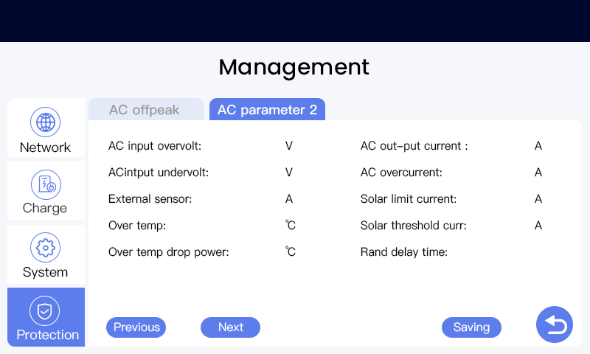

**Fig. 4-8**

4.6.4 Set parameters on the web page

. Step 1: the same LAN router connect to EVSE with RJ45 line.shown as Fig. 6-9.

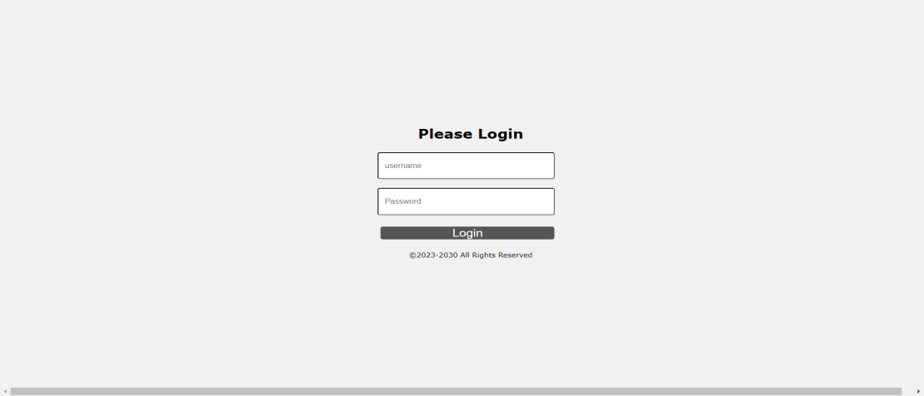

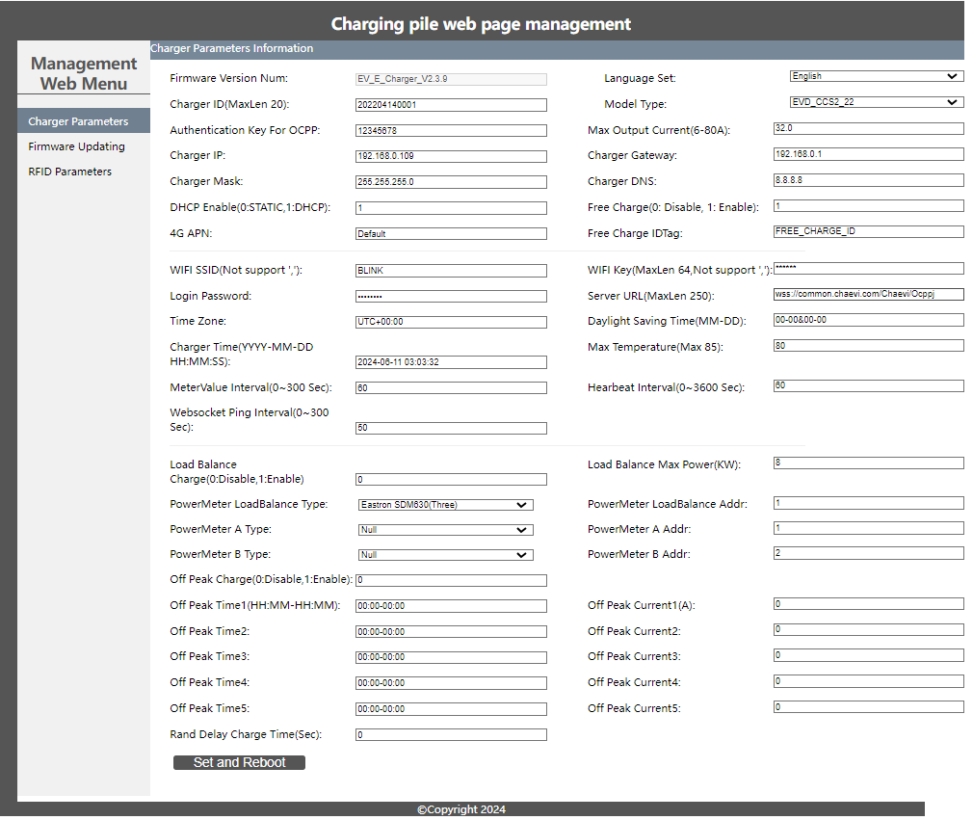

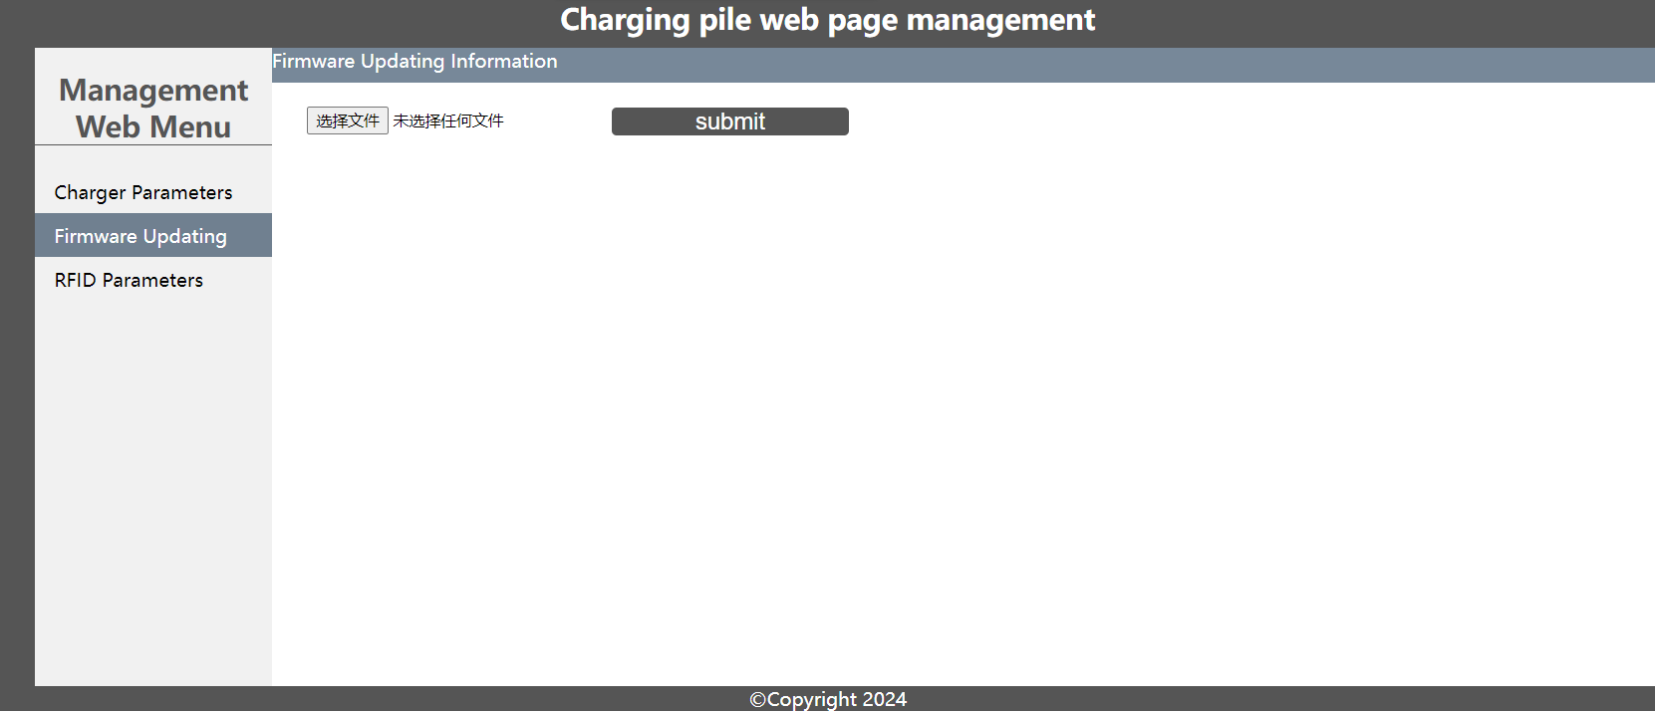

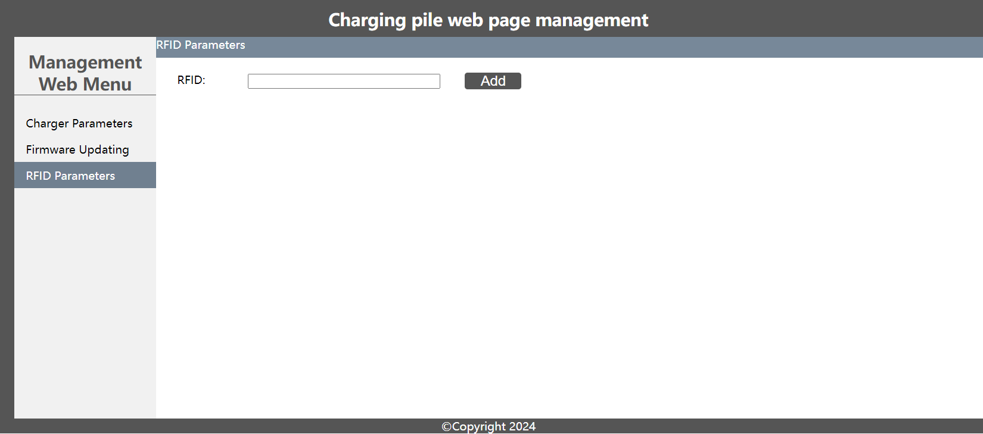

1）Select Wi-Fi Module

Select Wi-Fi modes and ﬁll in SSID and Password according to your application, if not required, just keep default.

(2)Version number, charging pile number Server address can be changed&set;

(3) Set the number and type of charging piles,

Module type and number. temperature. Meter etc can be changed also;

1. Fireware Updating:

Select an upgrade file to perform the upgrade

1. RFID Parameters

Select the rfid file to import the binding card function

**4.8 Configure parameters(static IP)**

Taking the configuration of charging station parameters by laptop as an example, it is introduced as follows (the method of setting parameters by mobile phone is

similar and will not be repeated):

.Step 1: Connect to EVSE with RJ45 line.

.Step 2: Keep your laptop in a state where it LAN use static IP [192.168.1.9](192.168.1.100)9, default gateway [192.168.1.1](192.168.1.253), network mask <255.255.255.0>. Connect to

the EVSE with RJ45 line.

.Step 3: By this setting the EVSE use a static IP [192.168.1.9](192.168.1.253)9. Now you can use[http://192.168.1.9](http://192.168.1.253/)9 to login to the manage web.

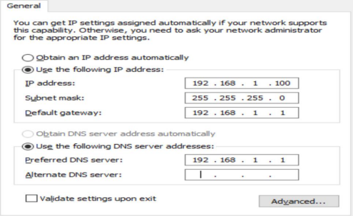

Fig. Setting PC LAN network

**4.9 Start Charging**

**Note: The vehicle to be charged must be parked, switched off and the parking brake engaged.**

a) Park your EV into place, turn off, and put the EV under braking.

b) For tethered (cable) version: Remove the Type 2 cable from the plug holder of the EVSE on the right side by pushing the button on the holder.

For untethered (socket) version: Plug in the Type 2 plug of the charging cable into the EVSE socket on the right side.

c) As shown in Fig. 6-13, plug the charging connector into the AC charging socket of the EV, and the LED of the charging station lights yellow.

d) For the mode of “Plug and play” charging station, the charging process will start automatically after plug in.

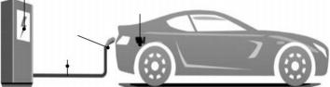

Vehicle inlet

Vehicle connector

Cable

Fig. 6-13 Plug into EV

e) For the mode of “swipe card” or “scan QR code” charging station, follow the instructions on the LCD screen after charging connector plug in, you can

start charging process by swipe RFID card or scan QR code.

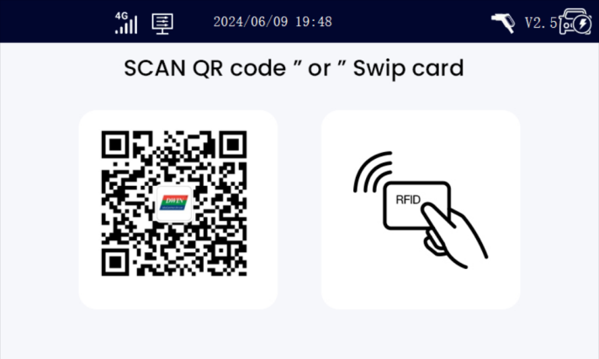

Fig. 6-14 Display of LCD screen after plug in

**4.10 Normally stop charging**

a) The charging station will automatically stop when the electric vehicle is fully charged.

b) For the mode of “plug-and-charge” charging station, you can manually stop charging as follow: press the unlock button of the remote key of the EV, the vehicle will stop charging (requires the support of the EV); if the charging

does not stop, you may try to unplug the charging connector directly. When “Charging” indicator turns off, the charging process is end.

For the mode of “swipe card” charging station, swipe your RFID card again when “Charging” indicator turns off, the charging process is end.

c) For the mode of “Scan QR code” charging station, click the stop button on

your APP, the charging will stop.

d) When the charging is end, please unplug the charging connector and plug back to the empty socket of charging station.

**4.11 Abnormally stop charging**

a) Forced fault stop: A fault stop initiated by the onboard charger of vehicle.

b) Automatic fault stop：A fault stop initiated by the charging station.

**5 FAULT HANDLING AND MAINTENANCE**

**5.1 Fault Handling**

The charging station is automatically protected in the event of the fault. The fault information and handling methods are as follows.

**Fault**

**information**

**Handling method**

**LCD Show**

LCD is off

CP failure

Emergency stop

 None

 EV Communication Error

 E-stop

 Check whether the power supply and distribution are normal;

 Check whether the branch breaker is tripped, and close the breaker after

troubleshooting;

 Check whether the connection is

correct, if the cable comes off, should be properly connected to tighten the cable.

 Check that the adapter is properly

connected to the electric vehicle, pull and plug the adapter and try charging again

 Check if EVSE is working properly and release emergency stop button by

turning it around.

**Fault**

**information**

**Handling method**

**LCD Show**

Under voltage fault

Over voltage fault

Over

temperature fault

Meter failure Leakage fault

Over current fault

No diode at

vehicle end

Relay sticking fault

Ground fault

 Under Voltage

 Over Voltage

 High Temperature

 Power Meter Failure

 Over DC 6MA

 Over Current Failure

 EV Communication Error

 Power Switch Failure

 Ground Failure

 Check that the input cable is reliably connected, that the parent grid is

properly connected, and that the grid voltage is abnormal.

 Check whether the input cable is

connected correctly; Whether the grid voltage is abnormal.

 Check whether the charging station is covered or installed in a high

temperature environment.

 Power off and restart the device

 Check whether the charging adapter and its cable are damaged or wet.

Recover after pulling out the adapter.

 Check whether the charging adapter is correctly connected to the car, and

check whether the on-board charger is normal

 This car is not up to standard and cannot be recharged

 The device is damaged and needs to be returned to the factory for repair

 The charging pile is not grounded, so the circuit needs to be tested

**5.2 Maintenance**

To ensure the long-term stable operation of the equipment, please maintain the

equipment regularly (usually every month) according to the operating environment.

a) The equipment is maintained by professionals.

b) Check whether the equipment is well grounded and safe.

c) Check whether there are potential safety hazards around the charging pile, such as whether there are high temperature, corrosion or

inflammable and explosive articles close to the charging station.

d) Check whether the join point of the input terminal is in good contact and whether there is any abnormality. Check whether other terminal points are loose.



We hereby declare, that this device carries the CE mark in accordance with the regulations and standards. It

conforms with the fundamental requirements of the RED

Directive 2014/53/EU. EMC Directive 2014/30/EU, and the Low Voltage Directive 2014/35/EU. The full text of the EU declaration of conformity is available at the following internet address: blinkcharge.com

**NOTE ON ENVIRONMENTAL PROTECTION**

After the implementation of the European Directive 2012/19/EU in the national legal system, the following applies:

Electrical and electronic devices may not be disposed of with

domestic waste. Consumers are obliged by law to return electrical and electronic devices at the end of their service lives to the public

collecting points set up for this purpose or point of sale. Details of this are defined by the national law of the respective country. This symbol on the product, the instruction manual or the package indicates that a product is subject to these regulations. By recycling, reusing the

materials or other forms of utilising old devices, you are making an important contribution to protecting our environment.